\*\*\*\*\*\*\*\*\*\*\*\*\*\*\*\*\*Classification\*\*\*\*\*\*\*\*\*\*\*\*\*\*\*\*\*\*\*\*\*\*\*\*\*\*\*\*\*\*\*

Weather dataset

<https://storm.cis.fordham.edu/~gweiss/data-mining/weka-data/weather.nominal.arff>

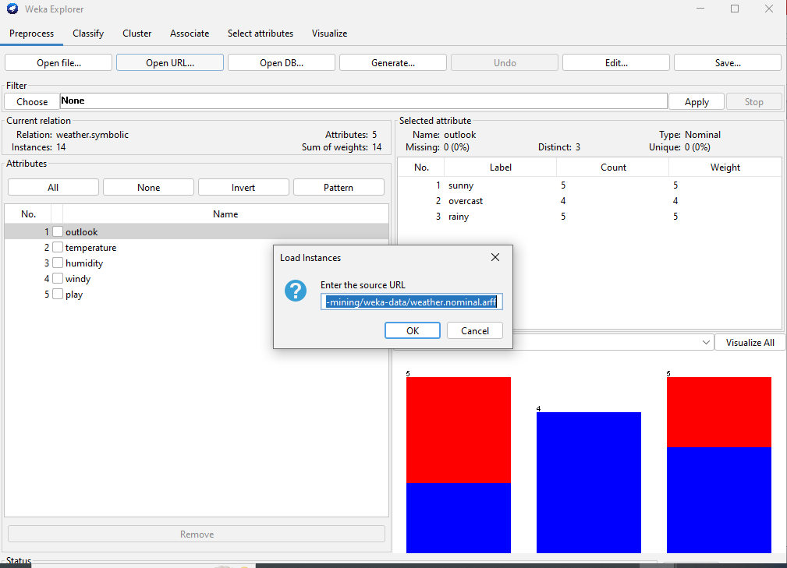

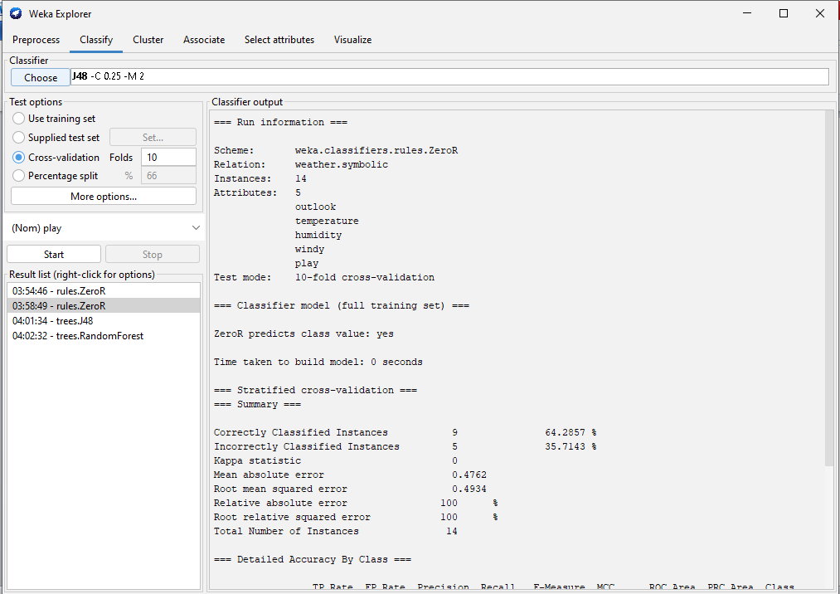

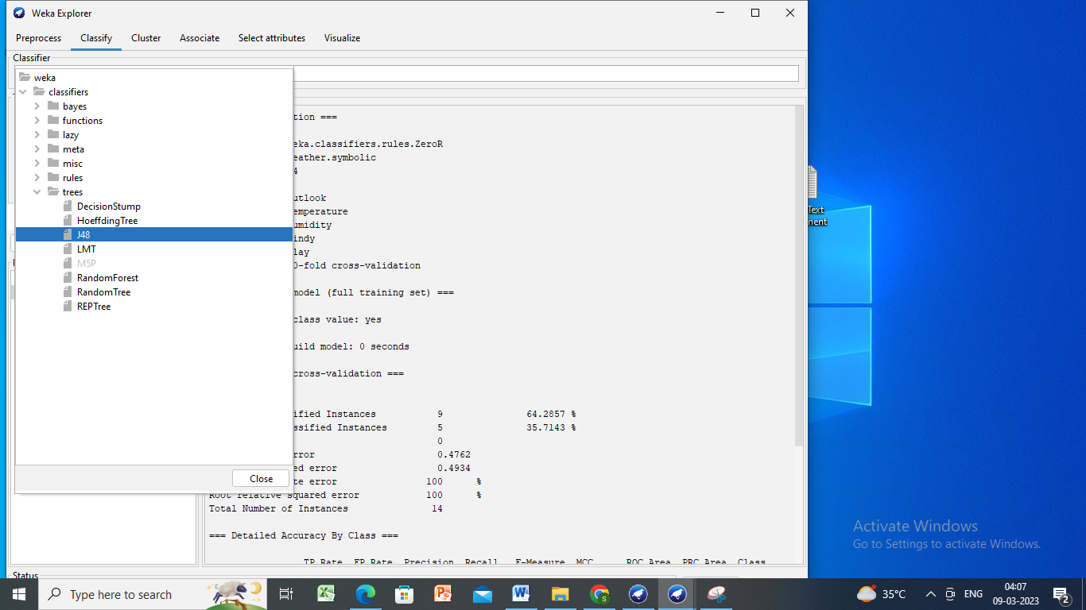

Click cross folds=10 and then start

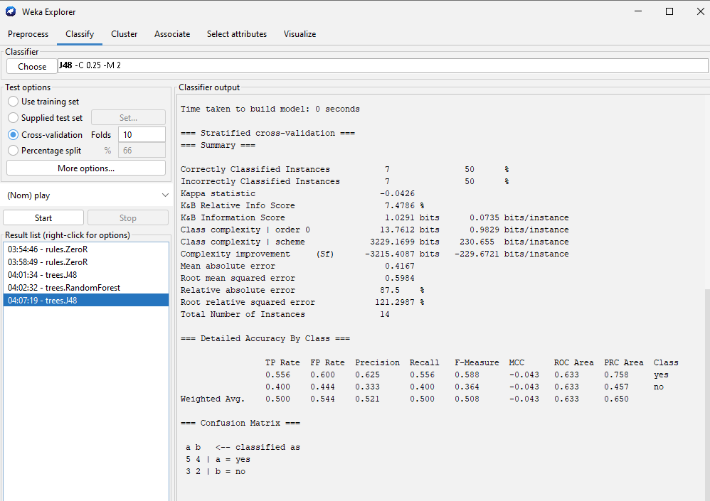

Right click in result list -🡪visualise tree

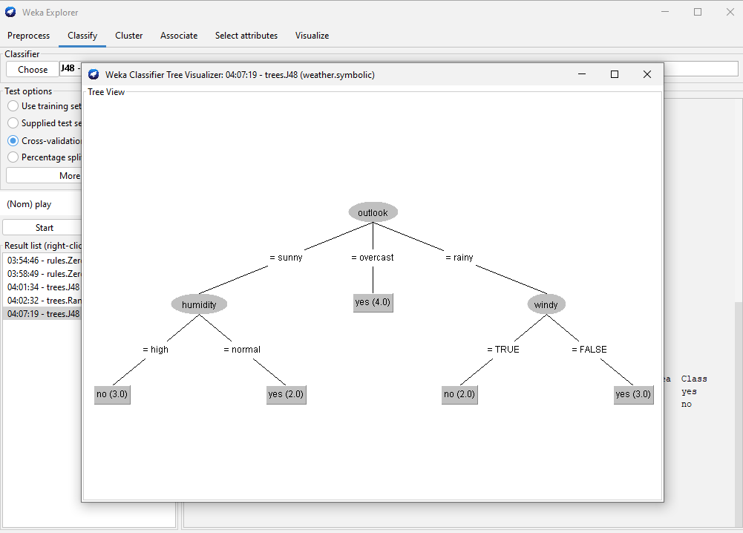

\*\*\*\*\*\*\*\*\*\*\*\*\*\*\*\*\*Clustering\*\*\*\*\*\*\*\*\*\*\*\*\*\*\*\*\*\*\*\*\*\*\*\*\*\*\*\*\*\*\*\*\*\*\*\*\*\*\*\*\*\*\*\*\*\*

Download Iris dataset

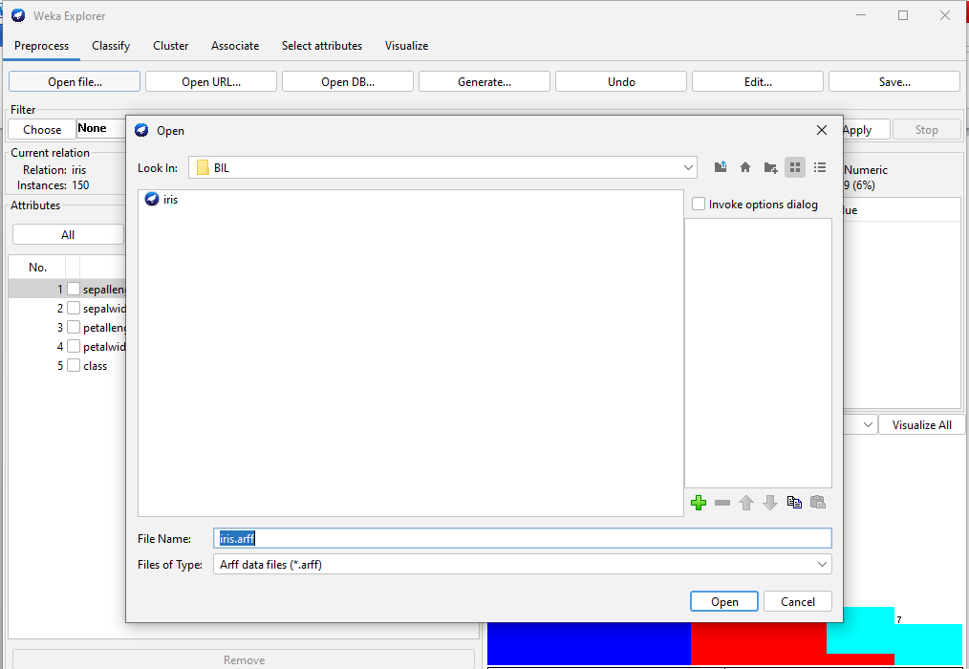

Click on cluster then on choose

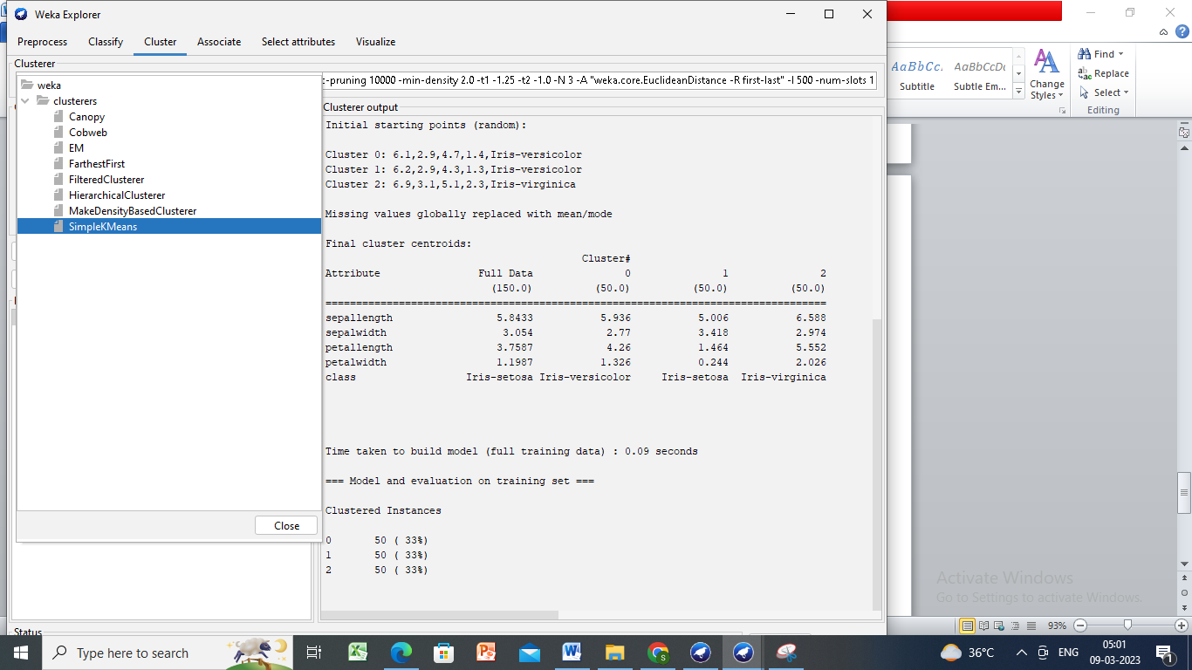

Right clik on simple k means in choose text box to open these properties.

Make changes Number of clusters=3

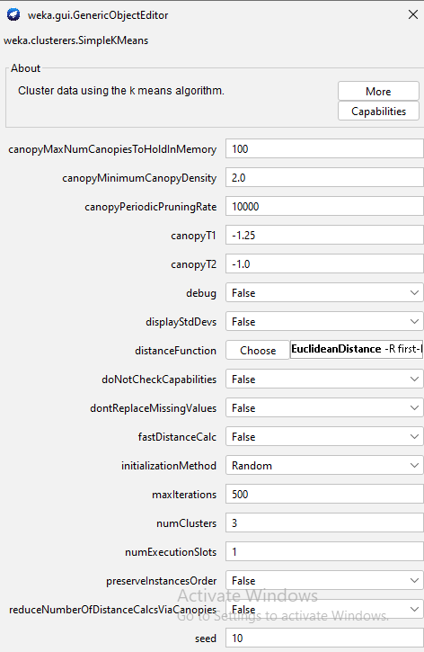

select use training set and then start

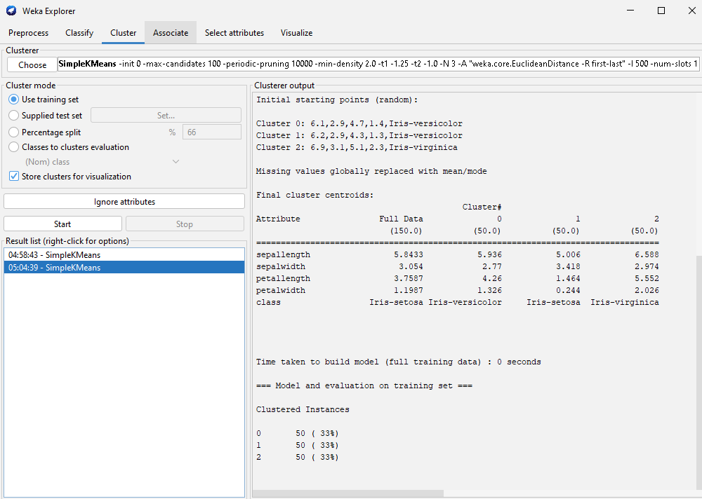

To visualise right click on simplekmeans in result list 🡪view cluster assignments

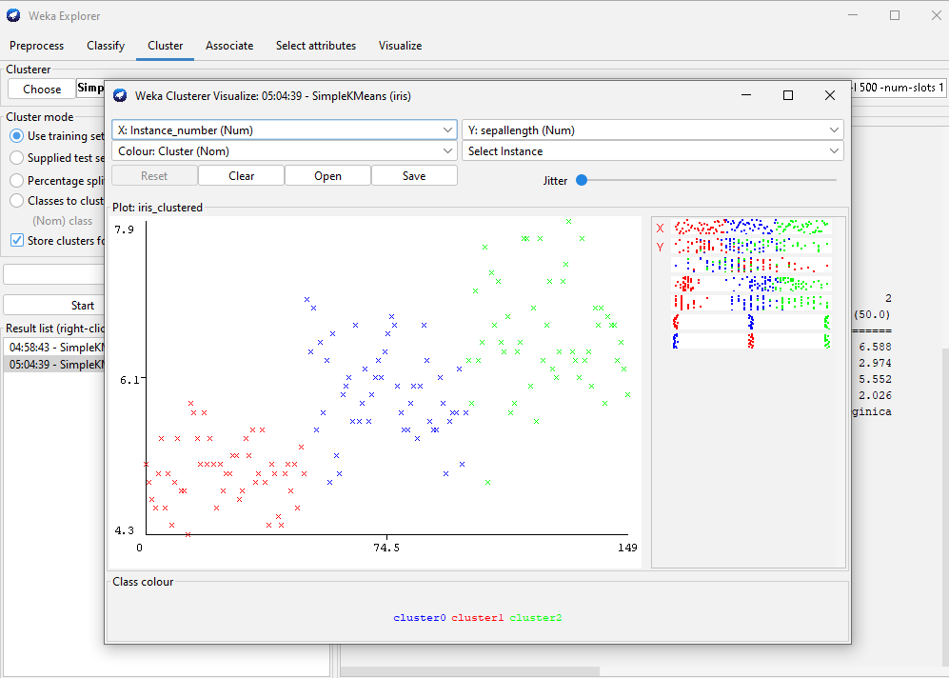

\*\*\*\*\*\*\*\*\*\*\*\*\*\*Frequent pattern mining\*\*\*\*\*\*\*\*\*\*\*\*\*\*\*\*\*\*\*

Save the dataset in notepad with contact-lenes.arff.

Open weka and click Explorer and then open file



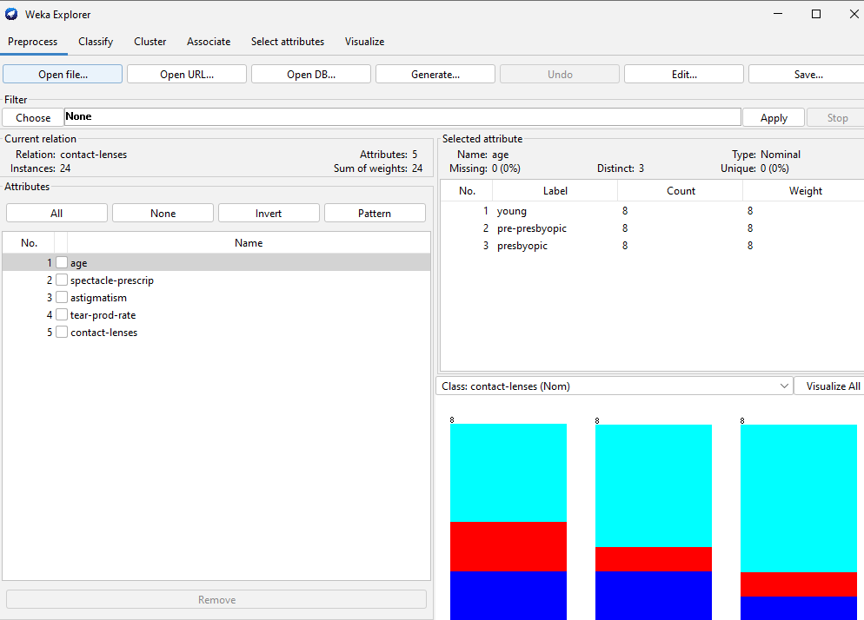

Click Associate and then choose Apriori

Then click start to get the output

